Pathantoli, Chowmony

Double mooring, Chattogram

**Mobile- 01677-997319**

**Email-**[sohagbubtcse@gmail.com](mailto:sohagbubtcse@gmail.com)

15 October 2023

The Head of Human Resource

Enosis

House 27, Road 8, Gulshan, Dhaka-1212, Bangladesh.

**Subject:** Application for the post of **“Senior Software QA Engineer”**

Dear Sir,

In response to your job advertisement published in linkedin.com dated 13 Oct 2023. I would like to introduce myself to you as I believe I have the skills, qualifications, and experience necessary to make a significant contribution to your organization.

I have got my B. Sc degree in CSE from BUBT University.

I have 3 years of experience as a SQA Engineer. I am self-motivated, energetic, enthusiastic and ever-ready to learn new things. I am confident to ensure the highest level of professionalism and commitment to my job.

I believe working in a reputed organization like yours will provide me with an excellent opportunity for my career. I would truly be grateful if I am finally selected for that post. I will prove myself to be an important asset to your company through my dedication, sincerity, and highest level of professionalism.

Sincerely,

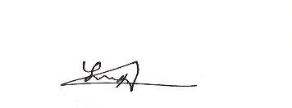



Mohammad Sohag